**ASSIGNMENT - 3**

**Rohan Panda - 2017A3PS0487H**

**Rayyan Shaikh - 2017A3PS0351H**

**Introduction:**

For this assignment an experiment based on tossing coins and predicting the distribution of the probability of getting heads is conducted.The dataset has 160 tosses with 70% of the tosses being heads and rest being tails, i.e. μ = 0.7.. The data assumes Bernoulli’s distribution and we have taken our prior distribution to be that of the gamma function. Predicting is then done in two different methods i.e.:

1. Sequential learning
2. Complete data learning

The results are shown as follows.

**Part-A)** **Sequential Learning**

The μML chosen is 0.7. The distribution is seen to be converging to having a mean at 0.7 from its prior mean which starts at 0.4.



------------------------------------------------------------------------------------------------------------------------

**Part B) Complete Data Learning**

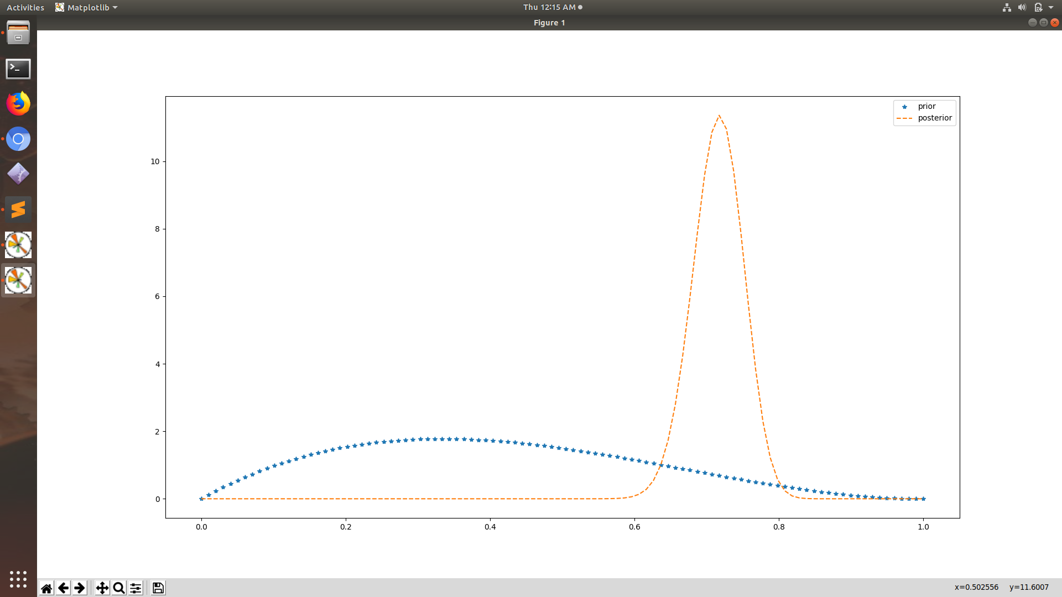

Here , the blue graph represents the prior and orange depicts the posterior distributions.

If the data’s μML is changed to 0.5 then our posterior’s distribution ends up with mean at 0.5 .

The below graph shows the same.

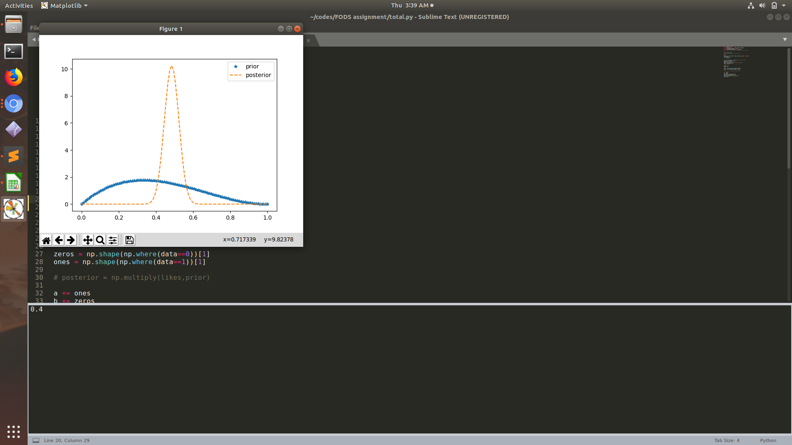

-----------------------------------------------------------------------------------------------------------------------

**Part C) Inference**

Both sequential and batch approach give the same end result since the posterior distribution of a beta function after seeing the data is also a beta function with parameters a = a+ o , b = b + z, where a , b are the parameters of beta distribution and o, z are the number of ones and zeros in the experiment. However, we get an inferential view on the learning approach in the sequential method.